Lesson 10 – CSS Colors

**CSS Colors:**

- Read: <https://www.w3schools.com/css/css_colors.asp> (only until HSL Value)

- Find any online **color picker service** and obtain HEX codes for the following colors:

* red, green, blue, white, black, yellow, purple, orange

**CSS Backgrounds:**

- Read: <https://www.w3schools.com/css/css_background.asp>

- Complete exercises [[1]](https://www.w3schools.com/css/exercise.asp?filename=exercise_background1), [[2]](https://www.w3schools.com/css/exercise.asp?filename=exercise_background2), [[3]](https://www.w3schools.com/css/exercise.asp?filename=exercise_background3), [[4]](https://www.w3schools.com/css/exercise.asp?filename=exercise_background4), [[5]](https://www.w3schools.com/css/exercise.asp?filename=exercise_background5)

**Task:**

A goal of this task is to upgrade **your website** to modern HTML/CSS standards. Your task is to move all of the *style declarations* outside of individual HTML files to the *external stylesheet*, hence separating the content and visual style.

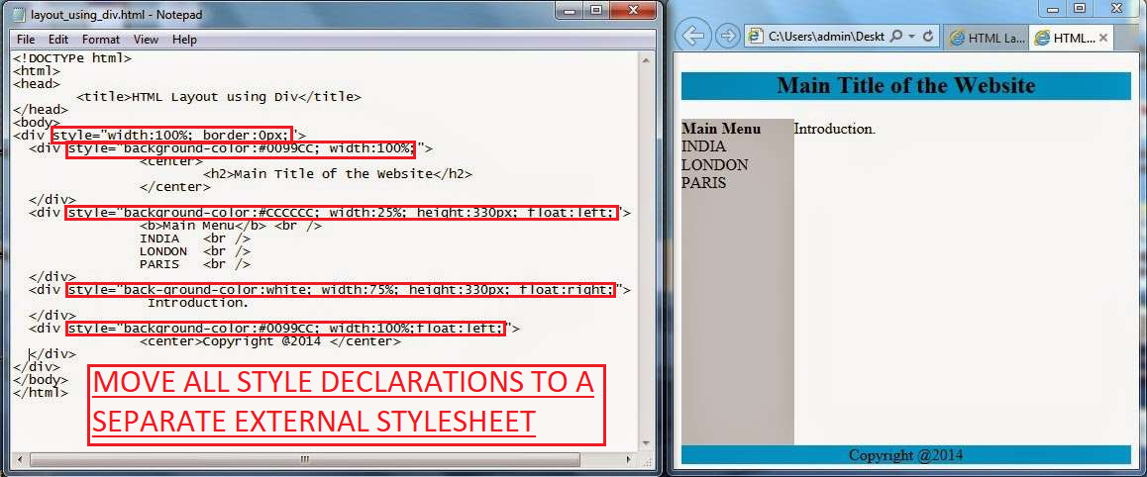

First, make a **copy** of your website. Then, edit all the styles used within **your website** copy as follows:

1. **Create** a single [external](https://www.w3schools.com/css/css_howto.asp) **stylesheet** that will be used for all of the HTML pages. You can name it *styles.css* an leave it empty, for now.
2. **Link** the CSS *stylesheet* to all of the HTML *pages* using the reference:
   * <link rel="stylesheet" type="text/css" href="styles.css">

or this one (for pages in a subfolder):

* + <link rel="stylesheet" type="text/css" href="../styles.css">

1. **Delete** all of the **inline style attributes** from your *HTML files*.
   * You can *make a temporary copy* of removed style declarations in any txt file, since you will need those later.
2. **Replace** the deleted style attributes with proper **class attributes**. Use *classes* such as:
   * header, navigation, content, footer, image1, para1, heading1, etc.…
3. **Move** all of the removed **style declarations** to the newly created external *CSS stylesheet*:
   * Use [class selectors](https://www.w3schools.com/cssref/sel_class.asp) for all the *classes*.
   * Add *former declarations* next to these selectors.

Finally, try to change a background **color** of your website, if you have not done so yet:

* Add a *single declaration* for background-color of *any element* into your stylesheet.
* After this, *all the HTML pa*ges should automatically reflect this change.